Interventions and preconceptions: Steps 7 & 8 of the roadmap (document 5)


Step 7: Interventions – What affects what?

Interventions are the deliberate actions you are going to take to trigger something to happen, or to prevent something from happening. Crucial to the Theory of Change, what domino effect are you going to trigger?
Before deciding on these, you need to choose a project:
- Go back to your problem statement in Step 3 (The Problem Tree) and choose one problem or topic.
- Using the description of the problem, come up with a title for a change project that reflects the problem you are going to solve.
- Now, create a vision statement of how you want the future to look: what you want to achieve in the next 2-3 years to increase the use of Welsh.
Here’s a prompt to help you create that vision statement:
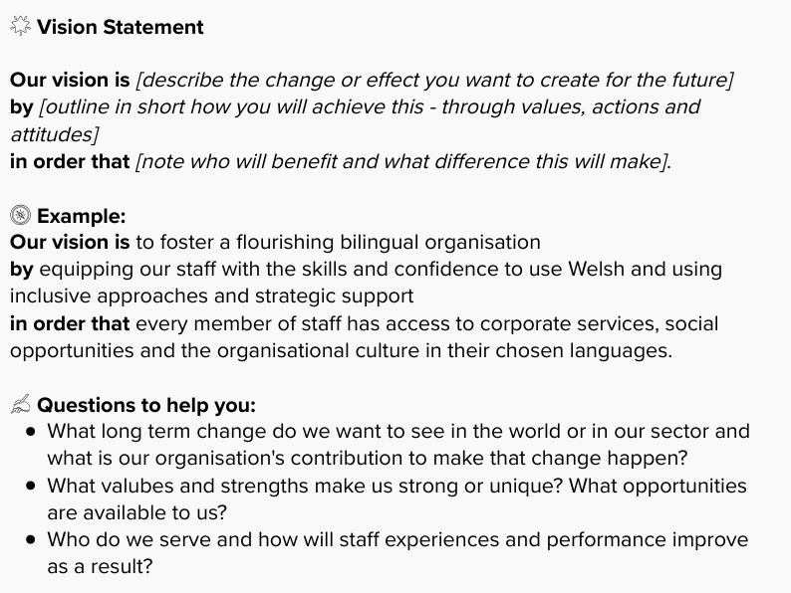
Now, with the vision of the change you want to see in your mind, think about 3-5 possible interventions. Interventions are the purposeful actions you can take or implement that will create a domino effect – with one thing leading to another, and as a result, you are aiming to realise your vision, i.e. the change/solution to the problem.

An Example: Domino Effect
- We believe that providing simultaneous translation for staff meetings will encourage Welsh speakers and learners to present and ask questions in Welsh. We will know this when Welsh is used orally and in writing (on a PowerPoint, or in the Teams Chat) during staff meetings. As a result, the number and percentage of staff reporting that they hear and use Welsh in internal meetings will increase.
- Use the template in the Roadmap to generate ideas for possible interventions.
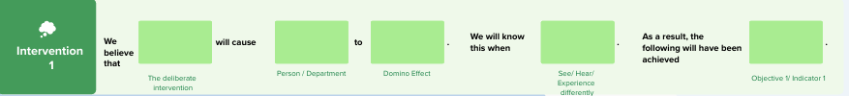

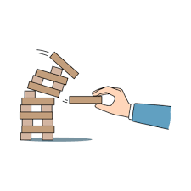
Step 8: Assumptions and Risks

Now, even if you have ideas about possible interventions to deploy, and how one thing will lead to something else, life is usually not that simple. You may have taken things for granted and without thinking about effects that will knock the chain of events you’ve planned or presumed off course.
It is necessary to identify any assumptions you made in Step 7. Note the assumptions and consider how you can overcome them. What can you put in place to reduce risk and increase your confidence that the interventions you have put in place will work and not be knocked off course?
There is a template for noting assumptions in Step 8 of the Roadmap.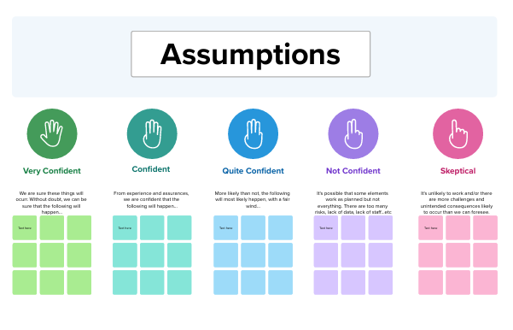
In the same way, identify the risks and any steps you can take to reduce, eliminate, and manage those risks. There is a simple template in the Roadmap, but you are welcome to use templates that are already available to you in your organisation.
