Using the Roadmap to Create a Theory of Change: A Step-by-Step Guide

To create a Theory of Change for your organisation, follow the 10 steps in the Roadmap below. The documents take you step by step through the 10 steps:
- Establishing the baseline,
- Understanding the legislative and policy context,
- Defining the problem and creating a business case,
- Creating a SWOT,
- Identifying stakeholders and influencers,
- Understanding dependencies,
- Designing interventions,
- Assessing and managing risks and assumptions,
- Creating a theory of change,
- Developing an action plan
There is also guidance on creating a monitoring and evaluation plan.
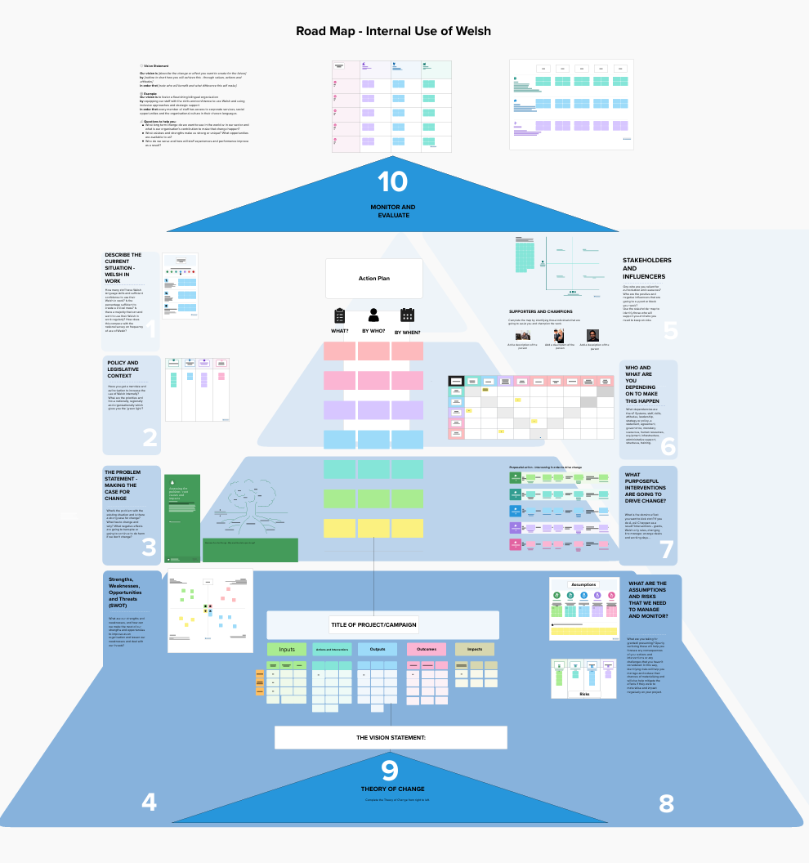

You can fill in the templates in a workshop using the Roadmap above, or it is possible to use some – or all – of the 10 templates separately, picking and choosing what you require as you work through the 10 stages.
You can use the Roadmap at a strategic level and develop a high-level Theory of Change for the whole organisation. Similarly, you can use the Roadmap more than once to drill down in more detail and to tackle specific individual problems. Also, you can select some of the templates and it is not necessary to complete all of them each time.

