Analysing and defining: Steps 1 – 4 of the roadmap (document 3)
Contents
Analysing and defining: Steps 1 – 4 of the roadmap (document 3) 1
Step 1: Describe the current situation of Welsh in work – Skills profile, usage and attitudes 1
Step 2: Policy and Legislative Context – Aligning with priorities and securing agreement 3
Step 3: Defining the problem and making the business case for change 5
Step 4: SWOT Analysis 7


Step 1: Describe the current situation of Welsh in work – Skills profile, usage and attitudes
Start by describing the baseline. That is, describing the current situation of the Welsh language in your organisation. How many staff have the skills and confidence to use Welsh at work, and is this enough to increase its use? The data will highlight the problem and the gaps at present and will provide you with a baseline.
- What is the current language skills profile of staff by level? A profile by department, professional field, and work location would be useful.
- In addition, what information do you have on staff’s internal use of Welsh? Who uses Welsh for what activities and how often? Are there any interesting patterns of language use, e.g., by language level, work area, or department and work location?
- And thirdly, what data do you have on staff confidence in using Welsh and their reasons for using or not using Welsh? What data do you have on the staff’s attitudes towards the Welsh language and the internal use of Welsh? Confidence and attitudes are just as important as skills and abilities if you want to get beneath the surface of the situation and understand more about the reasons behind staff behaviour.
Complete the template in the Roadmap – Step 1:
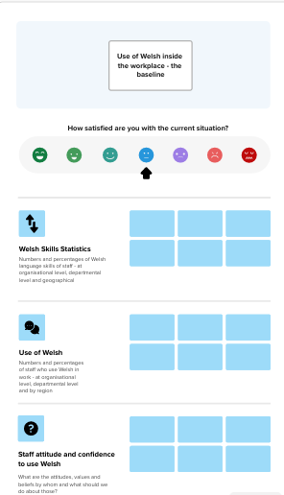
Collect both quantitative and qualitative data

National Survey – You will need to collect data regularly on skills, usage, and attitudes. How about considering mirroring the national survey questions so that you can compare with the community from where your staff come?
A critical mass of Welsh speakers is needed – consider how reports from the Commission for Welsh-speaking Communities are relevant to the Welsh language in the workplace. For example, 40% of Welsh speakers in a cluster will lead to more natural opportunities to use Welsh.


Step 2: Policy and Legislative Context – Aligning with priorities and securing agreement

Usually, permission from the organisation is needed to start a new project, and usually some kind of business case will need to be produced and presented. The purpose of Step 2, therefore, is to identify the strategic areas/priorities that align with your goal of increasing internal use of Welsh. You will need to show that there is a legal reason for doing this, but also that you are strategically aligning with the Welsh Government and the Commissioner’s strategy, as well as your corporate strategy, and that you have the mandate to do this in terms of scope and approval. Consider the context at a national, regional, and organisational level. You are looking for a lever to link Welsh with the organisation’s priorities.
  - Nationally - The policy models provide wording for you on the context but, as a matter of course, you would be expected to include the right to use Welsh at work (Welsh Language Measure (Wales) 2011), and the Operational Standard which sets requirements for bodies to create policies that promote the use of Welsh. Also, Welsh Government’s ‘Cymraeg 2050’ strategy and the Commissioner’s Strategic Plan 2025-30 where the workplace is a priority.
  - Regionally – are there priorities in the region/community that influence your strategies and plans as an organisation. For organisations in the education sector, be sure to mention your remit and targets for increasing Welsh-medium provision and the Welsh Language and Education (Wales) Act 2025. Local authorities and national park authorities are also required to develop a 5-year strategy setting out how you propose to promote the Welsh language in your area. Each organisation will have connections with the community, the economy, and the Welsh language in the areas you serve. Whatever your purpose/remit as a body, whether a national park, museum, charity, or regulator, note how your specific work relates to the Welsh language. This will help you when you consider your long-term impacts regarding the Welsh language.
  - Organisational – bring together your strategies, business plans, targets and indicators, and any strategic priorities you have as an organisation. Note each one that is directly related to the Welsh language but also those that are more broadly connected, e.g. inclusivity, equality, providing quality services to the public. If you have several ideas for projects, this documentation will help you prioritise and focus on those that align with strategic and corporate priorities.
Complete template available at Step 2:
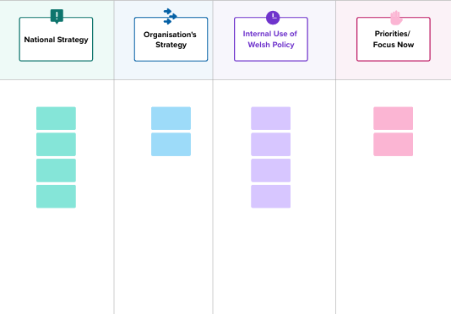


Step 3: Defining the problem and making the business case for change

The purpose of this step is to problematise the current situation to the point where you develop a business case that clearly shows why living with the current situation is no longer viable. The situation leads to undesirable consequences, and there are benefits and opportunities to be gained if the organisation were to change and move away from this problematic situation toward a better future.
Use the Problem Tree in Step 3 of the Roadmap for the brainstorming session to identify the main challenges and problems.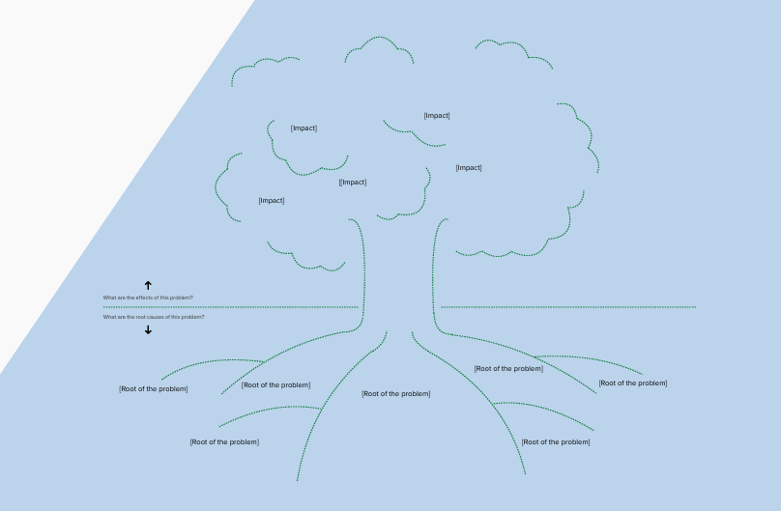
- Note in the branches and leaves of the tree what the impacts are – the negative consequences of remaining ‘as is’ as an organisation.
- Note in the roots of the tree, what the root causes of the problems are. What and why and due to whom do these problems exist. These will be your challenges, your obstacles, and your negative influencers who are currently preventing the increase in the use of Welsh internally.
- Now draw up a clear problem statement describing the problem you want to solve and why it must change/why the organisation can no longer live with the problem.

By the end of this stage, you will have a clear definition of the problem that needs to be solved. You can turn the problem definition into the title of the change programme/project you are going to propose to take forward.

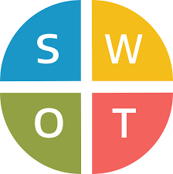
Step 4: SWOT Analysis

Specifically thinking about the problem in Step 3, decide on a specific topic and give the topic a name at the top of the SWOT template. Step 4 is analysing the strengths and areas for improvement and considering how exploiting your strengths and seizing opportunities can help tackle weaknesses and threats.
Keep a note of the good ideas that come out of the SWOT analysis because you might have come across the seed of an idea here for the next steps in the Roadmap.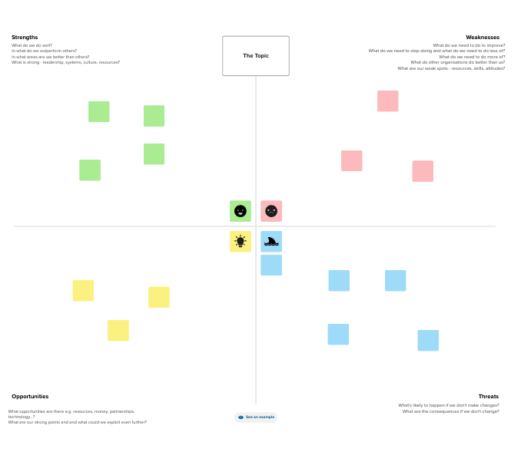

Arolwg defnydd iaith | LLYW.CYMRU Sample questionnaire - Arolwg Defnydd Iaith Holiadur ar gyfer oedolion 16+
Comisiwn Cymunedau Cymraeg | LLYW.CYMRU
The Problem Tree – Free template - FREE Problem Tree Template | Miro 2025

