Identifying stakeholders and influencers: Steps 5 & 6 of the roadmap (document 4)


Step 5: Stakeholder Mapping & Understanding Influences

The purpose of Step 5 is to identify who the good and bad influences are. That is, who is going to support, fund, drive, and promote this work, and who is going to oppose, undermine, and reject change. Identifying enablers is an important element in the Theory of Change, because recruiting these people and using their status, resources, energy, and commitment are major assets for you to succeed. In the same way, identifying and managing bad influences and blockers is just as important. Without tackling them, you are unlikely to succeed with your change project.
- Fill in the stakeholder map available in Step 5 of the Roadmap. The stakeholders in the top-left box are those with the most influence and power, who you need to make purposeful plans to engage with before, during, and at the end of your change project. The people in the bottom-right box are those to 'recruit' to the project team.
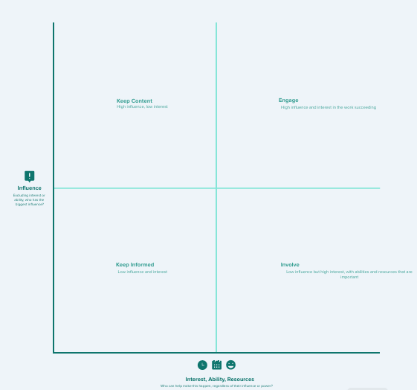

- Another exercise (which is optional) on the Roadmap is to identify your champions (optional). Individuals both inside and outside the organisation can influence your chances of success with a change programme. Consider who you need to ‘recruit’ as champions (in the loose sense of the word).

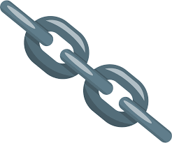

Step 6: Dependencies – Understanding what you are dependent upon

Identifying dependencies is an integral part of managing a change project because it is very rarely possible to work completely independently without any support, resource, or input from someone else. More often than not, a change project fails due to dependencies that have not been identified or dealt with in time or at all.
Timing and sequencing can also be important, because sometimes something important must occur as a precursor to something else.
Fill in the template (which is in grid form in the Roadmap, Step 6) to identify:
- the different teams that need to contribute to the work (down the left-hand side); and the
- actions that need to be completed/resolved for the team above to do their work.
The template available in the Roadmap is based on McKinsey's 7S’s.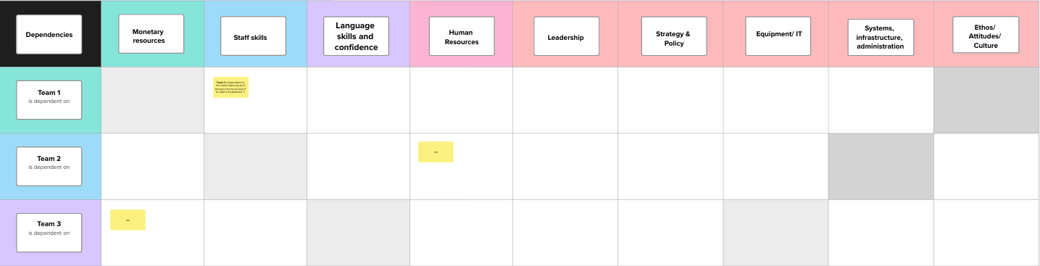

McKinsey outlines the 7S’s that need to be in place for an organisation to succeed. These are: Strategy, Structure, Style of Leadership, System, Staff, Skills, and Shared Values (Culture).
What are the systems that need to be in place? Are there processes or guidelines in place? Is there a strategy and policy in place? Are Welsh language skills required at an appropriate level? Is it necessary to communicate with staff about the change? Are there sufficient resources in place? What are the staff attitudes towards the change? Is there support and understanding from the unions?
The 7S’s fall neatly under the 3 themes in the model policies, which are leadership, infrastructure, and confidence building. The table below shows how these map. So think about the 7 elements when completing Step 6.
Leadership | Administrative Infrastructure | Building confidence
Corporate strategy aligned with the change.  Statements from senior leaders on the change. | Systems – Human resources, technology, policies and processes, systems that staff need to use to implement the change. | Staff capacity to implement the changes.  Staff skills and confidence with language.  Shared values – all staff behind the changes

