Creating a Theory of Change: Step 9 of the roadmap (document 6)

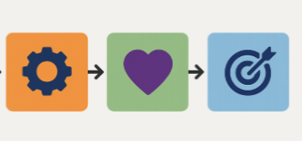
Step 9: Creating the Logic Model – Theory of Change

Now that you have done the preliminary work and created a comprehensive Roadmap, you are ready to fill in the Logic Model (Step 9). This is the main step.
Here is the template available for you to fill in:
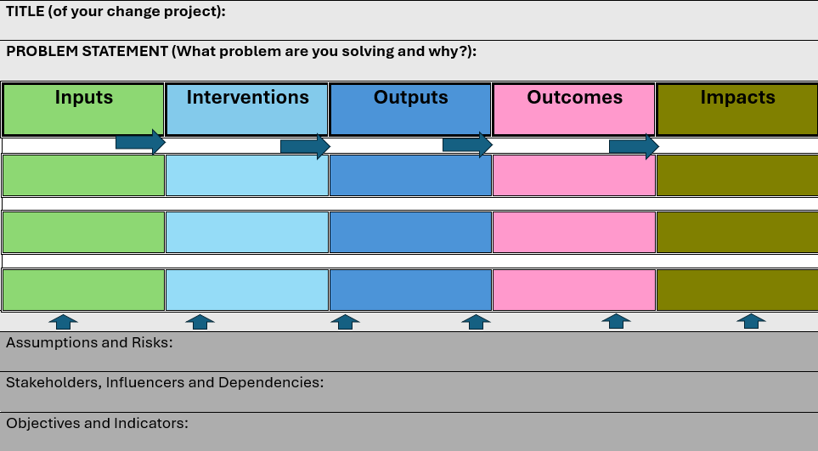
- Clearly write the name of the campaign/project and your vision statement on the top. Also describe the problem and the case for change.
- Now fill in the boxes starting from right to left, i.e., starting at the end.

With a logic model, you start in the future or at the end of the journey, i.e. what the change programme has achieved. You work backwards step by step, continually asking what had to happen for this to occur. Begin with the impacts you will see as a result of your work.
- List the long-term impacts
What change do you hope to see in terms of internal use of Welsh? What will the future look like if you have succeeded? How will you as an organisation contribute to the Commissioner's strategy to increase internal use of Welsh in the workplace and the Welsh Government's strategy to reach a million Welsh speakers and the day-to-day use of Welsh?
- Define the outcomes
What results do you want to see in the end? Perhaps hearing Welsh in meetings and in the workplace corridor on a daily basis? If your outcomes are achieved, they should lead to seeing the above ripple effects.
- Identify the outputs
These are the products or deliverables you will get as concrete outputs due to your work. For example, policy statements, rules, policies, events, folders and files, and internal documents in Welsh. But also remember softer outputs, e.g. how people behave and feel.
- List the inputs
Once you know what outputs need to be produced to create the outcomes and results you are aiming for, you can now list the core inputs needed to kick start the change programme.
Consider inputs such as money, people, skills, equipment, infrastructure, leadership from senior managers, and permission to do the work.
Language training, language awareness, translation services, and staff skills and confidence are essential. Remember to consider the foundations and the 7S’s outlined in Part 1 of this guide.
- Assumptions
These are the things that are going to influence the relationship between the inputs, the outputs, the outcomes, and the impacts (positively or negatively). It is necessary to understand these and plan for them in order to reduce unexpected and negative influences from affecting your programme while you are in the middle of implementation. Consider the following:
- The connections between inputs, outputs, and outcomes – does A follow on to B and C, or what have you taken for granted? What will be able to influence and interfere at any stage and as it moves to the next stage?
- Practicality of the project/work – do you have sufficient resources, what else is happening within the organisation and externally that will affect your work?
- Are everyone’s responsibilities clear and does everyone agree/see eye to eye and is ready?
- Are the skills, resources, and attitudes going to support the work and allow the work to happen?
- Assess the risks
By carrying out a risk assessment exercise and identifying actions and mitigation steps, it is more likely that your project will succeed. It is also an effective way to raise issues within the organisation when obstacles or difficulties arise, and a way to share responsibility and accountability for an organisational change project.

