Measuring progress and evaluation: Step 10 of the roadmap (document 7)


Step 10: Monitoring and Evaluation Plan

The final step is to plan your monitoring and evaluation work. Monitoring is needed during the change programme, i.e. while implementing, and at the end, after completing the project and looking back.
During the process of implementing the change, it is useful to monitor and evaluate to learn lessons and improve interventions based on the experience of how the situation is developing and what is working well and not so well. Even though you have planned, it is quite common for interventions to cause unexpected consequences that can disrupt your plans and take them off course. Monitoring for negative signals and unexpected and harmful side effects is an important part of monitoring implementation. This gives you the opportunity to influence negative unintended consequences and adjust or add interventions to keep the change programme on the right track.
At the end of the project/change programme, evaluating how successful the work has been is very important. This assessment is going to show you the extent to which you have achieved the outcomes and had a broader impact on your medium- and long-term goals. The findings will help you demonstrate the value for money of your project/change programme and identify the next steps for another project to move further along the continuum of Welsh language use within the organisation: foundation, proactive, and innovative.
As part of this Resource pack, there is a sample template that you can fill in. You do not have to complete the column on signals, but it is important to define indicators – these are the critical factors to measure whether you have succeeded in the medium to long term. These need to align with the outcomes in your Theory of Change. Also consider whether these align with any goals in your internal use of Welsh/promotion policy and strategies.
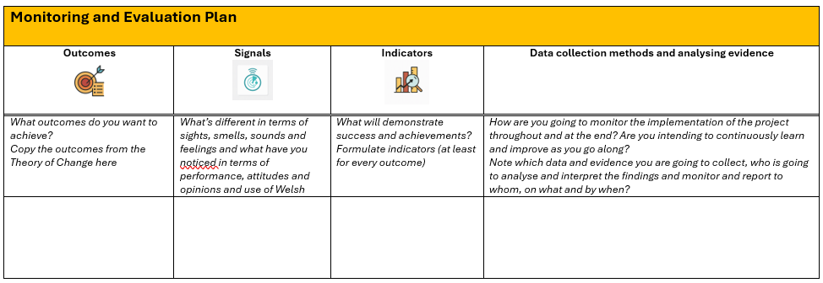

In the last column, there is space for you to note the monitoring and evaluation methodologies. This is the 'how' you are going to collect and analyse the data. For example, language use surveys will be key, and consider which specific use of Welsh is to be measured, e.g., which staff meetings, which written work, and which corporate services. Also, remember to consider more qualitative data to understand attitudes, confidence, and staff behaviour, that is, why they use more Welsh or not. Focus groups are good for gathering information.
Use this column also to note personnel, resources, and timing for different monitoring and evaluation tasks. It is important to consider drawing on specialist resources such as in-house researchers/evaluators and to consider commissioning independent work to evaluate the change programme.

Next Steps: Formulating an Action Plan/Project Plan
Now you are ready to draw up a project/action plan and secure your organisation's authorisation for the resources and commitment to undertake this transformation.
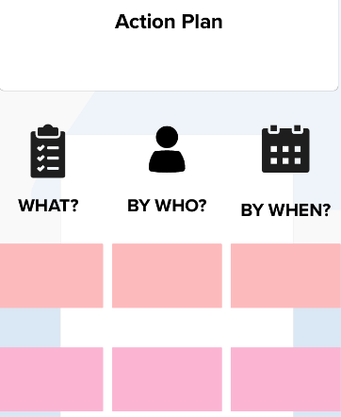
After obtaining approval on the above, it is essential to create an Action Plan that includes all the activities that need to be carried out, by whom, and by when. The template is in the Roadmap is a very simple example of an Action Plan for illustrative purposes only. There is no doubt a template you already have in your organisation.
Note that an effective internal use policy should contain a detailed action plan, and the policy models also provide a template for you to use.
Whichever of the plans/templates you choose, this document will be crucial in helping you coordinate all the work, but it is also an important tool for monitoring colleagues’ progress across the organisation to ensure that everyone who depends on others stays on track. The action plan is also an important tool for reporting progress to senior leaders and for keeping departments accountable for their actions within the project.
The Plan will also include how you will report how successful you were in ultimately achieving the outcomes and how successful you have been in contributing to creating 1 million Welsh speakers by 2050 by increasing the use of Welsh in your workplace.

